**9.3 Physiology of stress**

Every person experiences stress throughout life which can provide then stimulus for change or growth. Some stress is positive and even necessary for healthy lifestyle. However too much stress in life can result in poor adjustment and serious consequences on physical and mental health and inability to cope.

Stress affects all dimention of a person’s life such as physical, mental , social, psychological and emotional. The amount of energy required and the effectiveness of the attempt to adapt depend on the intensity, scope and duration of the stress or and the number of other stressors.

The body has a preserving mechanism that automatically comes in times of stress or danger. During stress and crisis, nervous, endocrine and immunological systems are most commonly affected which includes CNS, ANS, adrenal glands , lymph glands that affects all organs of the body.

If the body response to stress, hypothalamus is stimulated, then sympathetic nerves prepares the body for self- defense. The reaction is protective and involuntary response which preserves health by major defense mechanisms, for examples extenal defense, inflammatory response, immune system. These systems work together to send impulses to the brain through the ganglia to prepare the body for ‘fight or flight’ response. The amount of energy released as well as effectiveness of adaptation depends on intensity, duration and number of stressors.

There are two types of stress responses:

* Physiological response
* Psychological response

**Physiological Response**

Physiological response to a stressor is ‘fight or flight’ response in which the body prepares itself for survival. There are three major homeostatic mechanisms: medulla oblungata, Reticular formation and pituitary gland.

1. Medulla oblongata:

* Control vital functions (increase or decrease)- heart rate, blood pressure, respiration

1. Reticular formation

A small cluster of neurons in the brainstem and spinal cord, controls vital functions and monitors the physiological status of the body through connections with sensory and motor factors. For e.g cause a sleeping person to regain consciousness or can increase a person’s level of consciousness when a need arises.

1. Pituitary gland

* Supplies numerous hormones (Regulated by feedback mechanism) to control vital functions and to adapt to stressors.

There are two types of adaptations seen in stress as

1. Local adaptation syndrome
2. General adaptation syndrome
3. Local Adaptation syndrome

Local adaptation takes place within a single organ, tissue or system or specific area. It is the method used to control the effects of physical stressor or stress locally, where one organ or part of body reacts alone. e.g. inflammation, reflex pain response.

When the stressor cannot be handled locally, the whole body responds to protect itself and ensures survival in the best way possible through the general adaptation. The four characteristics of local Adaptation syndrome are:

* the response is localized
* doesn't involve entire body system
* adaptive responses are short term
* assist in restoring homeostasis to the body

1. General adaptation syndrome

It is the physiological response of the whole body to stress. It is also called neuro-endocrine response as it primarily involve autonomic nervous system and endocrine system.

The general adaptation syndrome has 3 stages. They are

1. Alarm stage
2. Resistance stage
3. Exhaustion stage
4. Alarm stage

The initial reaction to stress is alarm stage, which alters the bodily defenses. This stage is an instantaneous, short term, life preserving, and total sympathetic nervous system response; when a person consciously or unconsciously perceives a stressor, feels helpless, insecure, or biologically uncomfortable. Selye divided this stage in to two parts:

* Shock phase
* Counter shock phase

1. **Shock phase**

During shock phase, the stressor may be perceived consciously or unconsciously by the person. This stage is known as "flight or fight" reaction, in which autonomic nervous system reacts.

The anterior pituitary increases production of adrenocorticotropic hormone that stimulates adrenal cortex to produce glucocorticoids (hydrocortisone) and mineralocorticoids (aldestorone).

These catecholamine triggers increased sympathetic nervous system activities, which stimulates production of epinephrine and nor- epinephrine by the adrenal medulla and release at the adrenergic nerve endings. The alarm reaction also stimulates the pituitary to release anti- diuretics hormone. This primary response is short lived lasting from one minute to 24 hours.

b.**Counter shock phase**

The second part of the alarm reaction is the counter shock phase, where the changes produced in the body during the shock phase are reversed with the intensification of stress opposite behaviors are observed. These are due to effect of parasympathetic activity, because here is proximity between sympathetic and parasympathetic nerve fibers. Thus, a person is best mobilized to react during the shock phase of the alarm reaction (the person is prepared to act, more alert and able to adapt).

1. **Stage of Resistance**

The second stage of the GAS is the stage of resistance, where person starts to adopt the stress through adopt the stress through adrenocortical response. In other word, the body attempts to cope with the stressor and to limit the stressor. Stress to the smallest area of the body that can deal with it.

Because of adrenocortical response, tissue anabolism, antibody production, secretion of hormone and changes in blood glucose and blood volume sustain the body's fight for preservation, then body response eventually returns normal. If stress occurs over a long period without adequate relief, the stage of resistance is maintained, and the person becomes distresses and manifests objective and subjective emotional, intellectual and physiological responses.

1. **Stage of Exhaustion**

In this stage, the adaptation that the body made during the second stage cannot be maintained. This means that the ways used to cope with the stressor have been exhausted. If the adaptation has not overcome the stressor, the effects may spread to the entire body. At the end of this stage, the body may either rest and return to normal, or death may be the ultimate consequence.

Stage of exhaustion occurs when the person is unable to continue to adapt to internal and external environment demands. Because body can no longer compensate for homeostatic imbalances, disease or death may result.

Manifestations of this stage are similar to those of the alarm stage. The end of this stage depends on the adaptive energy resources, severity of the stressor and external adaptive resources.

Frequently GAS responses triggers disease:

* Adrenocortical hypertrophy
* Thymolymphatic atrophy
* Elevate blood glucose
* Ulceration of GI tract

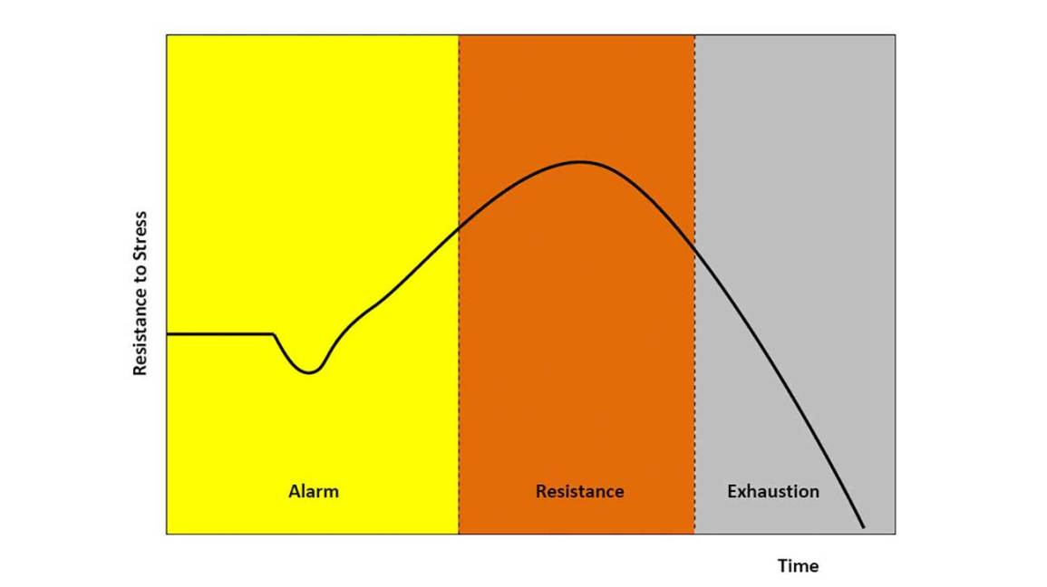

Fig: pictorial presesntation of GAS

**Psychological Responses**

Psychological adaptive behaviour is self-centred and acquired through learning and experience to coping mechanism for stress management. Its purpose is to regulate one’s emotional distress and thus protect oneself from anxiety and stress. Psychological adaptive behaviours can be both constructive and destructive. Constructive behaviour helps an individual accept the challenges to resolve conflict where destructive behaviour affects person’s problem solving abilities, personality .

Healthy individual in normal circumstances is able to cope with every day moderate stress by following two mechanism:

1. Task oriented behaviors
2. Ego-defensive mechanism
3. Task oriented behavior

Involves a person’s cognitive abilities to solve problems and reduce or avoid stress. Its types are;

* Attack behavior- an action taken to remove or overcome stresses or to satisfy a need.
* Withdrawal behavior- simply removes oneself physically or emotionally from the stressors.
* Compromise behavior- changing one’s usual method of substituting goals, or omitting the satisfaction of needs or avoid stress.

1. Ego-defensive mechanism

They are habits and affections that exist to protect the individual sense of self.

According to Sigmund Freud, they are unconscious psychological mechanisms that are used to reduce the anxiety that arises from unaccecptable or potentially harmful stimuli, thoughts or desires. They are;

* **Compensation**: concealing difficulty by developing in another direction
* **Conversion**; expresion of an intrapsychic conflict as a physical symptoms like blindness, deafness, paralysis, numbness.
* **Denial**: refuse to accept external reality as it is too threatening.
* **Regression**: temporary reversion of the ego rather than handling unacceptable impulses in a more adult way.
* **Idealization**: tending to perceive another individual as having more desirable qualities than he or she may actually have.

**Summary**

When stress occurs, a person uses physiolgical and psychological energy to respond and adapt. The physiological response to a stressors is a protective and adaptive mechanism to maintain homeostasis balance of the body. There are of two responses; local adaptive syndrome (LAS), General adaptive syndrome (GAS). In Local Adaptive Syndrome, response is localized and doesnot involve entire body. In General adaptive syndrome, there are 3 stages;

Alarm stage- known as flight or fight response in nervous system. In this stage, stressors trigger the body response to stress.

Resistance stage- the pituitary stops that large secretion of hormone and the effects of the alarm phase lessen. It is the body’s way of adapting, through an adrenocortical response, to disequilibrium caused by the stressor.

Exhaustion- occurs when the person is unable to continue to adapt to internal and external environmental demands.one feels exhausted, he has no strength to deal with the stressors anymore.

A healthy individual develops psychological adaptive behavior to cope with stressors. Psychological adaptive behaviour can be constructive or destructive.